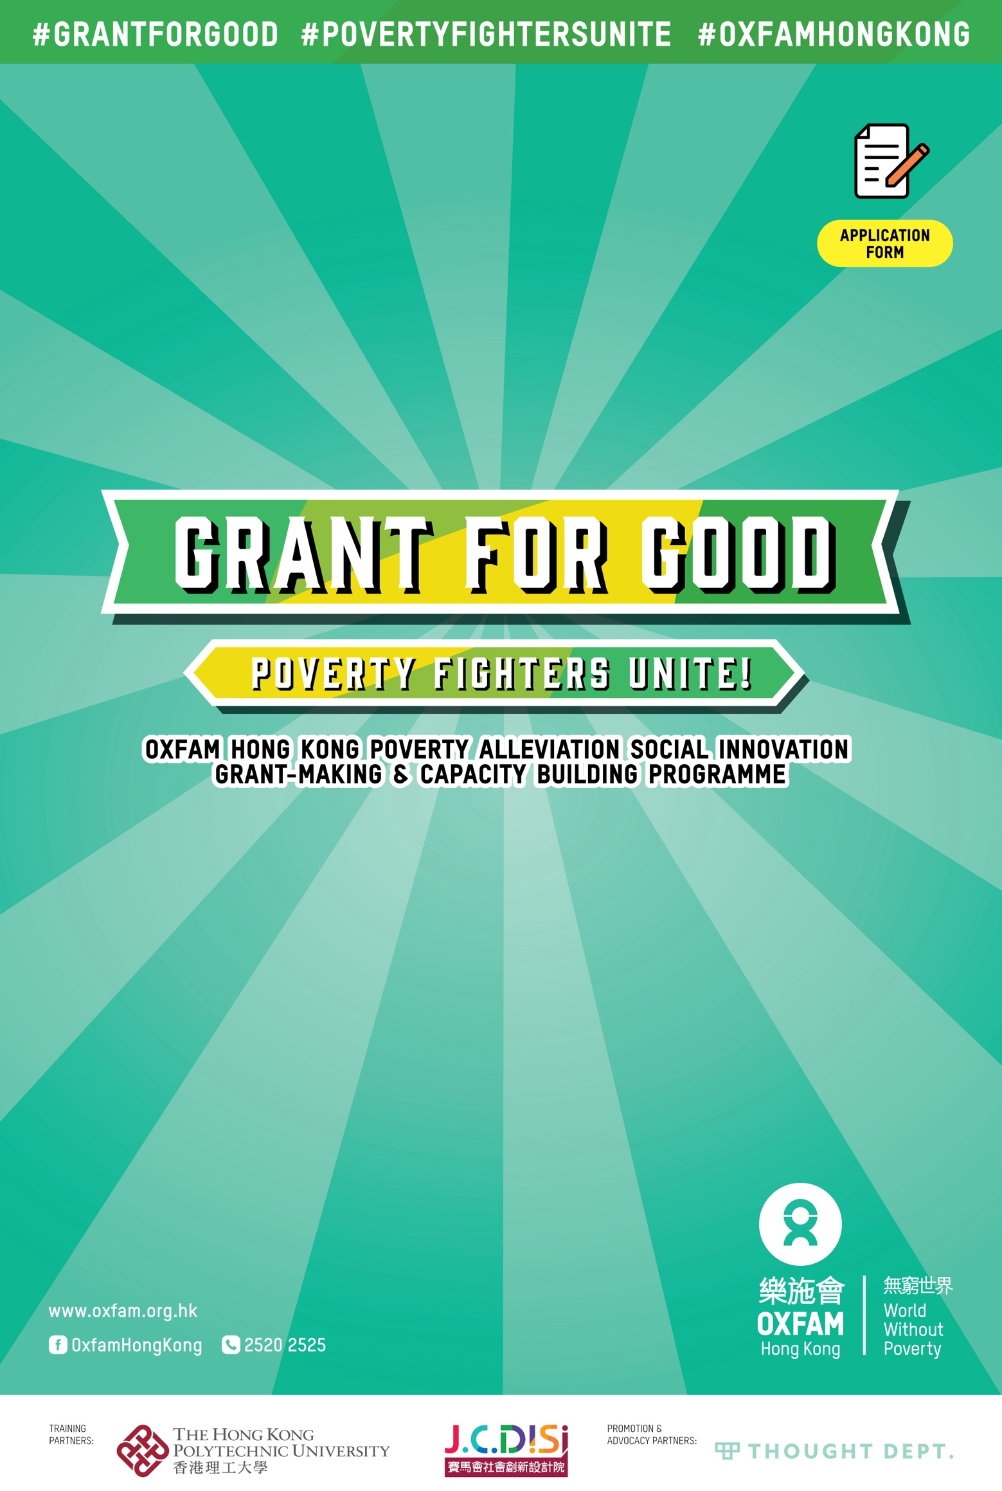
* | Please read the Application Guidelines for the ‘Grant for Good - Oxfam Hong Kong Poverty Alleviation Social Innovation Grant-making & Capacity Building Programme’ before completing this form.
** | This form needs to be completed jointly by members of the team.
*** | Please tick (✓) as appropriate.
**** | Form Submission: Via email: grant4good@oxfam.org.hk  By post: 17/F, China United Centre, 28 Marble Road, North Point, Hong Kong  (please write ‘Application for Grant for Good’ as the subject line / on the envelope)
You are cordially invited to join ‘Grant for Good’. The initiative encourages creative, ground-up efforts from the community to alleviate poverty. To apply, please work with your team to complete this application form and draft a preliminary proposal for your poverty alleviation project (i.e. ‘Part III’ of this application form), bearing the tagline of the programme in mind: ‘Poverty Fighters Unite! Take Action in Communities to Combat Poverty’). Oxfam Hong Kong will consider all applications during the first round of evaluation. Shortlisted teams will participate in a unique training programme jointly developed by Oxfam Hong Kong and the Hong Kong Polytechnic University’s Jockey Club Design Institute for Social Innovation. The programme will help participants fine-tune their action plans, to make their proposal more impactful and feasible. This will also help improve teams’ chances of obtaining the HK$200,000 grant to implement their project.
Part 1: Basic Information of Organisation and Team

1) Organisation Name
Chinese:
English:

2) Team Category (please choose one)
( ) Limited company incorporated under the Companies Ordinance | Registration No.:
( ) Unlimited company under the Companies Ordinance | Registration No.:
( ) Bodies incorporated under the Societies Ordinance | Registration No.:
( ) Bodies incorporated under the Partnership Ordinance | Registration No.:
( ) Bodies incorporated under the Co-operative Societies Ordinance | Registration No.:
( ) Other statutory bodies established under the laws of Hong Kong,
please specify the nature of organisation:
( ) We intend to form a company/society, but have not formally established one yet.

3) Is it a charitable institution or trust of a public character granted tax exemption under section 88 of the Inland Revenue Ordinance?
( ) Yes ( ) No

4) Do you have a bank account under the same name as the registered organisation?
( ) Yes ( ) No
( ) If other arrangements apply, please specify:

5) Core Team Members (recommended team size: 3 to 5 members)
Each shortlisted team must select a core group of 3 to 5 members to participate in all five sessions in the training programme. The team’s chances of receiving the grant will be affected if they are unable to attend all sessions. For more details, please refer to the ‘Grant for Good - Oxfam Hong Kong Poverty Alleviation Social Innovation Grant-making & Capacity Building Programme’ application guidelines.

Name of Core Team Member | Role/Title in the Team | Project-related Skills/ Profession/ Experience | Contact | A permanent resident of Hong Kong? | Between 18 and 35 years old? | If the team is shortlisted, can you attend all the sessions of the training programme? (Refer to application guidelines for tentative dates.)
Principal Applicant  Chinese:  English: |  |  | Telephone:  Email: | ( ) Yes  ( ) No | ( ) Yes  ( ) No | ( ) Yes  ( ) No
Chinese:  English: |  |  | Telephone:  Email: | ( ) Yes  ( ) No | ( ) Yes  ( ) No | ( ) Yes  ( ) No
Chinese:  English: |  |  | Telephone:  Email: | ( ) Yes  ( ) No | ( ) Yes  ( ) No | ( ) Yes  ( ) No
Chinese:  English: |  |  | Telephone:  Email: | ( ) Yes  ( ) No | ( ) Yes  ( ) No | ( ) Yes  ( ) No
Chinese:  English: |  |  | Telephone:  Email: | ( ) Yes  ( ) No | ( ) Yes  ( ) No | ( ) Yes  ( ) No

6) Referee (if any)
Name | Title, Organisation | Contact (email and telephone)

Part II: About Your Organisation

1) Aims and Objective of Your Organisation (please explain in 100 words)

2) Year of Establishment

3) Website

4) Current status (e.g. organisation structure/members/executive committee/number of staff, main work of the team to achieve the above objectives)

5) Main Sources of Funding

6) Has the team ever successfully applied for funding from any government, charity or private organisation?
( ) No
( ) Yes, please list below the name(s) of the funding agency and the duration (period) of the funding:

7) Project-Related Experience Within the Team
This includes any ongoing or previous projects or initiatives, relevant media coverage, competition or award-winning experience, event presentations and such. If there is an abundance of information and media content, we recommend highlighting key projects. You can upload large files to an online file sharing platform, grant us permission to access the files, and share the link below.

8) Why does your team want to participate in this project? (Please explain in 100 words or less.)

Part III: Preliminary Proposal
You are invited to share your ideas for the project. If shortlisted, teams will be required to participate in a five-session training programme (please refer to the application guidelines). Experts will support shortlisted teams to refine their project idea, and ensure that their solution is comprehensive, feasible, and impactful. The preliminary proposal teams submit is only a starting point for the scheme. There will be many opportunities for shortlisted projects to make adjustments and revisions afterwards.

If teams require assistance while filling out this section, please make use of the planning toolkit provided on the ‘Grant for Good - Oxfam Hong Kong Poverty Alleviation Social Innovation Grant-Making and Capacity Building Programme’ website, which will help teams to plan together.

1) Project Name / Tentative Name
Chinese:
English:

2) Current Stage of Your Project
We have
( ) not started and have not tested our idea yet
( ) not started and are in the process of iterative testing and revision
( ) started recently (less than a year, we have been operating for months)
( ) started, currently in operation (one year and above, we have been operating for years)
( ) Other, please specify:

3) What is the social problem/pain point that your team wants to address?
(Please explain in 100 words or less.)

4) What is the relationship between this problem and poverty? (Please explain in 100 words or less.)

5) There are many poverty-related issues in the world, why must the issue you mentioned be addressed? (Please explain in 200 words or less.)

6) How did this problem come about? Please analyse its causes.
(Please explain in 400 words or less.)
(If necessary, please use the ‘Fishbone Diagram’ and ‘Problem Tree’ planning tools for reference.)

7) Who has contributed to this problem? Who is most affected by this problem? Who has the most power to change this situation?
(There may be more than one party for each.) (Please explain in 400 words or less.)
(If necessary, please utilise the "Stakeholder Map" planning tool for reference.)

8) Who do you want to help or influence through this project? Why?
(You may have more than one type of target audience.) (Please explain in 200 words or less.)
(If necessary, please use the ‘Stakeholder Map’ planning tool for reference.)

9) To address the above social problems/pain points and their respective causes, what poverty alleviation project idea do you have in mind?
(If necessary, please utilise the ‘5W1H’ planning tool for reference.)
Introduce your project idea in 400 words or less.

Introduce your backup project idea (if the above idea is not feasible, you may choose to implement the backup project; this is an optional field, you may leave it blank). (Please explain it in 400 words or less.)

10) What do you want to achieve through your project?
(Please explain in 200 words or less.) (You may write in point form.)
(If necessary, please use the ‘SMART Framework’ planning tool for reference.)

11) What strategies will you adopt to actualise your project idea? What activities or events do you anticipate carrying out?
(Please explain in 400 words or less.) (You may write in point form.)

12) Who is the main target audience of the project? How many beneficiaries do you intend to reach through the project?
(Please explain in 200 words or less.) (You may write in point form.)

13) Highlight the creative elements of this project in 400 words or less.
Creativity can be in the form of new perspectives, new approaches or new technology; these can be used to solve problems, and/or identify and discover new and critical problems. The solution can be original, or it can be a great idea that has been implemented elsewhere that is worth replicating in our community. It can also be a new approach that improves existing practices and systems.

14) What impact or outcome do you expect to see after the completion of the project?
(Please explain in 400 words or less.) (You may write in point form.)

15) How much do you think this current proposal can be adjusted (on a scale of 0 to 10)? Which parts are likely to be adjusted, and which parts may not be adjusted easily?
Note: Shortlisted teams will have many opportunities to make adjustments and revisions to their plans during the training programme.

Score (0-10) 0 points: No room for adjustment 10 points: Every component is flexible and can be adjusted
Areas that are likely to be adjusted
Areas that may not be adjusted easily

16) Successful applicants may receive a grant of up to HK$200,000 to implement the project. How do you plan to use this money? Please share your rough estimates.
a. Is the project likely to generate revenue? (e.g. event fees, service fees, etc.) ( ) Yes ( ) No
b. Is a grant of HK$200,000 or below enough to cover the entire project? ( ) Yes ( ) No
c. Do you think that there will be other sources of funding involved for the project?
(e.g. self-funded, other funding programmes, etc.)
( ) Yes, please specify the source(s):
( ) No

Estimated Budget

a. Expenses
(Expenses may include project staff salaries, course instructor’s fees, and other personnel costs)

Item  Note: A rough estimate is sufficient, we recommend listing no more than 10 key items | Amount (HK$)
Total Amount (HK$)

b. Income
(if any; leave blank if not applicable)

Income items/sources | Amount (HK$)
Total Amount (HK$)

17) In early September 2021, Oxfam Hong Kong will conduct online consultation sessions for applicants. During the session, experts will provide suggestions for improvements based on the preliminary proposals submitted by the respective teams. After the sessions, teams will have the opportunity to resubmit a revised proposal before the application deadline. To ensure sufficient time for review and adjustment, teams that wish to participate in the sessions must submit their application form by 31 August 2021. Online consultation sessions are available on a first come, first served basis.
a. Is your team interested in participating in an online consultation session? ( ) Yes ( ) No
b. If you are interested in participating, which time slot is convenient for you?
(You may choose more than one time slot.)
Weekdays ( ) 10:00-14:00 (AM Session) ( ) 14:00-18:00 (PM Session) ( ) 18:00-21:00 (Evening)
Saturday ( ) 10:00-14:00 (AM Session) ( ) 14:00-18:00 (PM Session) ( ) 18:00-21:00 (Evening)
Part IV: Applicants’ Declaration and Consent Form (Please tick (✓) as appropriate.)
( ) I, the applicant, confirm that all members of my team have read the programme's application guidelines and instructions, and confirm that the team is eligible to apply for the programme.

( ) I confirm that, if selected, our team will assign 3 to 5 core members to participate in the training programme, which is comprised of five sessions in total.

( ) I hereby declare that all information provided in and attached to this application form are true and correct. I understand that if any false or inaccurate information is provided, or if any necessary information is omitted, the application will be deemed invalid.

Signature of
Principal Applicant
Name of
Principal Applicant
Signature of
Other Members
Names of
Other Members
Name of Organisation
Date

